EF Core 8.0 Guided Hands-On Exercises
Lab 1: Understanding ORM with a Retail Inventory System
Scenario:
You’re building an inventory management system for a retail store. The store wants to
track products, categories, and stock levels in a SQL Server database.

Output:
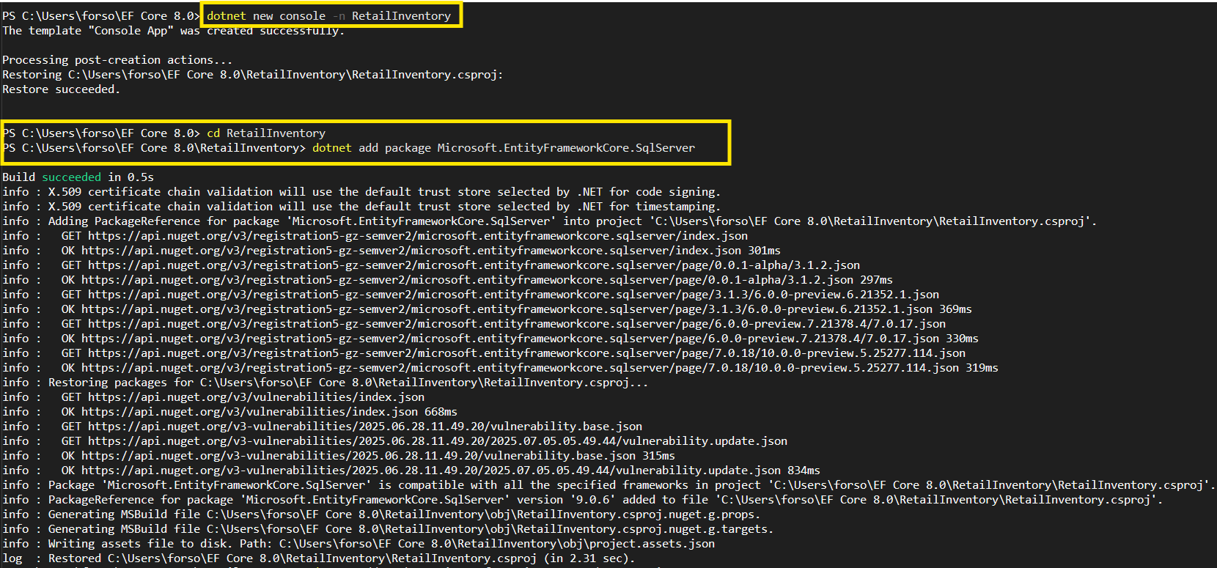
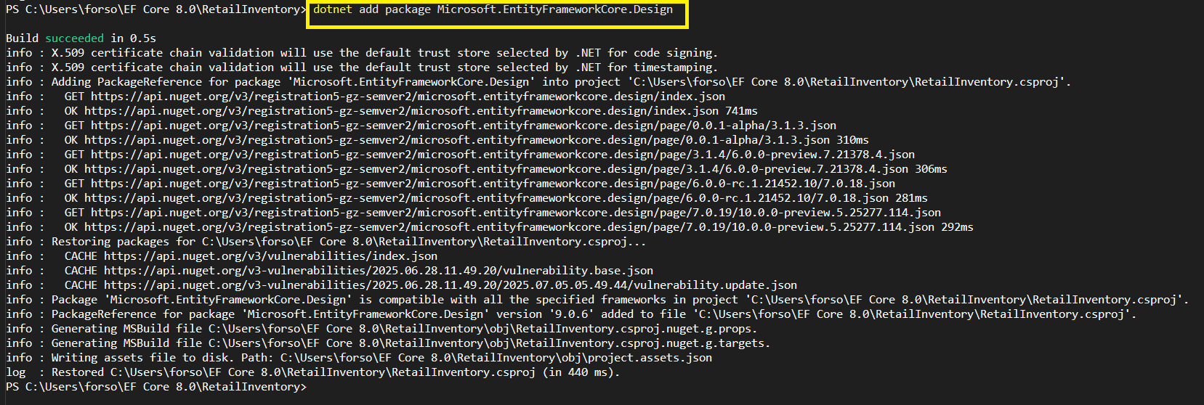
Code:
1. Create a .NET Console App:
dotnet new console -n RetailInventory
cd RetailInventory
2. Install EF Core Packages:
dotnet add package Microsoft.EntityFrameworkCore.SqlServer
dotnet add package Microsoft.EntityFrameworkCore.Design
Lab 2: Setting Up the Database Context for a Retail Store
Scenario:
The retail store wants to store product and category data in SQL Server.

Output:
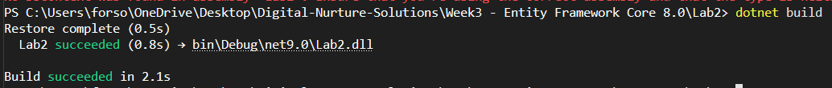

Code:
Models/Product.cs
using System.ComponentModel.DataAnnotations;
using System.ComponentModel.DataAnnotations.Schema;

namespace RetailInventory.Models
{
public class Product
{
public int Id { get; set; }

[Required]
[MaxLength(200)]
public string Name { get; set; } = string.Empty;

[Column(TypeName = "decimal(18,2)")]
public decimal Price { get; set; }

public int CategoryId { get; set; }
public Category Category { get; set; } = null!;
}
}
Models/Category.cs
using System.ComponentModel.DataAnnotations;

namespace RetailInventory.Models
{
public class Category
{
public int Id { get; set; }

[Required]
[MaxLength(100)]
public string Name { get; set; } = string.Empty;

public List<Product> Products { get; set; } = new List<Product>();
}
}

Data/AppDbContext.cs
using Microsoft.EntityFrameworkCore;
using RetailInventory.Models;

namespace RetailInventory.Data
{
public class AppDbContext : DbContext
{
public DbSet<Product> Products { get; set; }
public DbSet<Category> Categories { get; set; }

protected override void OnConfiguring(DbContextOptionsBuilder optionsBuilder)
{
// Replace with your actual connection string
optionsBuilder.UseSqlServer("Server=.;Database=RetailInventoryDB;Trusted_Connection=true;TrustServerCertificate=true;");
}

protected override void OnModelCreating(ModelBuilder modelBuilder)
{
// Configure relationships
modelBuilder.Entity<Product>()
.HasOne(p => p.Category)
.WithMany(c => c.Products)
.HasForeignKey(p => p.CategoryId);
}
}
}

Lab 3: Using EF Core CLI to Create and Apply Migrations
Scenario:
The retail store's database needs to be created based on the models you've defined.
You’ll use EF Core CLI to generate and apply migrations.

Output:
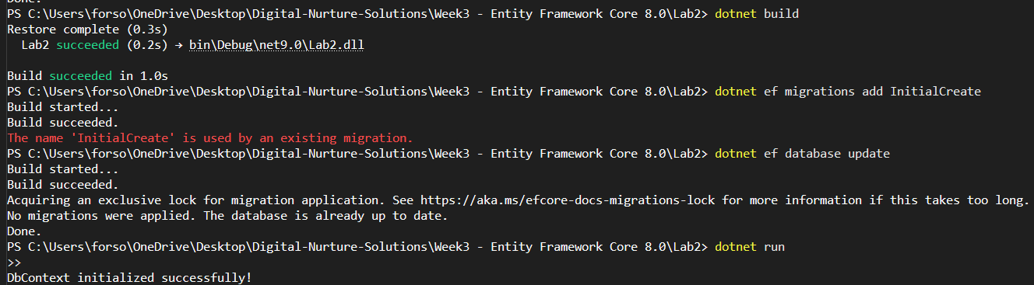
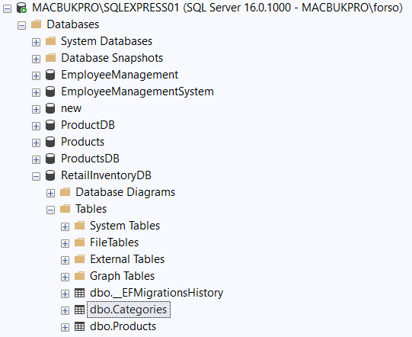
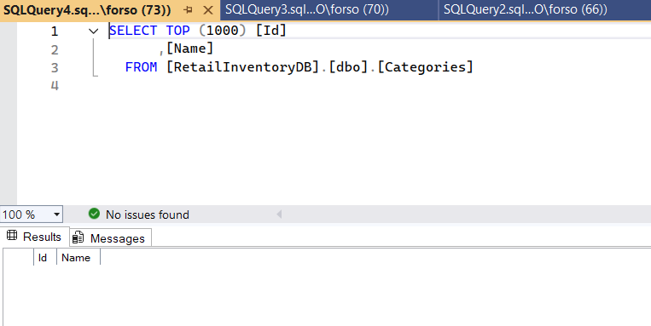
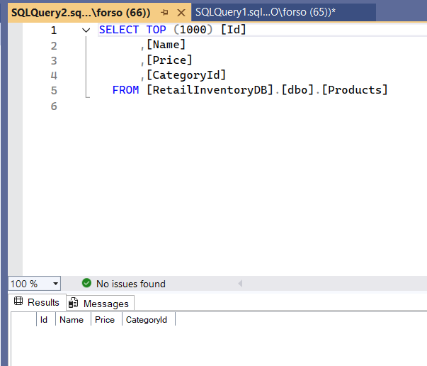

Code:
Program.cs
using Lab2.Data;
using Lab2.Models;
using Microsoft.EntityFrameworkCore;

Console.WriteLine("=== Retail Inventory System ===\n");

try
{
using var context = new AppDbContext();
await context.Database.EnsureCreatedAsync();
if (!await context.Categories.AnyAsync())
{
Console.WriteLine("Inserting initial data...\n");

var electronics = new Category { Name = "Electronics" };
var groceries = new Category { Name = "Groceries" };
var clothing = new Category { Name = "Clothing" };

await context.Categories.AddRangeAsync(electronics, groceries, clothing);

var products = new List<Product>
{
new Product { Name = "Laptop", Price = 75000, Category = electronics },
new Product { Name = "Smartphone", Price = 45000, Category = electronics },
new Product { Name = "Rice Bag (25kg)", Price = 1200, Category = groceries },
new Product { Name = "Cooking Oil (1L)", Price = 180, Category = groceries },
new Product { Name = "T-Shirt", Price = 899, Category = clothing },
new Product { Name = "Jeans", Price = 2499, Category = clothing }
};

await context.Products.AddRangeAsync(products);
int recordsAffected = await context.SaveChangesAsync();

Console.WriteLine($"✅ Successfully inserted {recordsAffected} records!\n");
}
else
{
Console.WriteLine("⚠️ Data already exists. Skipping insertion.\n");
}
}
catch (Exception ex)
{
Console.WriteLine($"❌ Error: {ex.Message}");
}

Lab 4: Inserting Initial Data into the Database
Scenario:
The store manager wants to add initial product categories and products to the system.

Output:
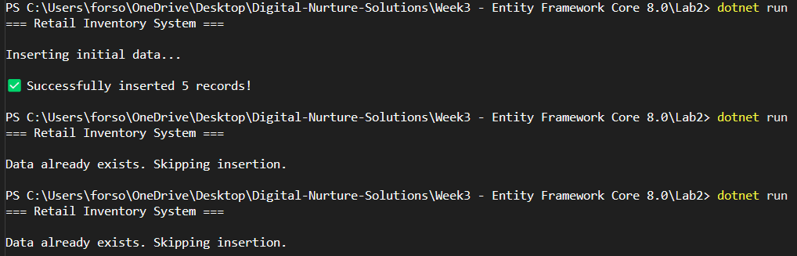
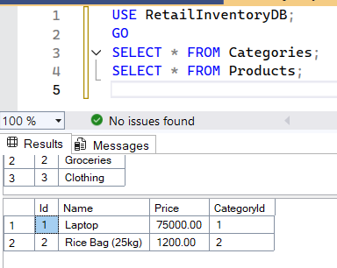

Code:
Program.cs
using Lab2.Data;
using Lab2.Models;
using Microsoft.EntityFrameworkCore;

Console.WriteLine("=== Retail Inventory System ===\n");

try
{
using var context = new AppDbContext();

// Ensure database is created
await context.Database.EnsureCreatedAsync();

// Check if data already exists
if (!await context.Categories.AnyAsync())
{
Console.WriteLine("Inserting initial data...\n");

// Create categories
var electronics = new Category { Name = "Electronics" };
var groceries = new Category { Name = "Groceries" };

var clothing = new Category { Name = "Clothing" };

await context.Categories.AddRangeAsync(electronics, groceries, clothing);
// Create products
var products = new List<Product>
{
new Product { Name = "Laptop", Price = 75000, Category = electronics },
new Product { Name = "Rice Bag (25kg)", Price = 1200, Category = groceries },
new Product { Name = "Jeans", Price = 2499, Category = clothing },
};

await context.Products.AddRangeAsync(products);

// Save changes
int recordsAffected = await context.SaveChangesAsync();
Console.WriteLine($"Successfully inserted {recordsAffected} records!\n");
}
else
{
Console.WriteLine("Data already exists. Skipping insertion.\n");
}
}
catch (Exception ex)
{
Console.WriteLine($"Error: {ex.Message}");
}

RetailInventoryDB:
USE RetailInventoryDB;
GO
SELECT * FROM Categories;
SELECT * FROM Products;

Lab 5: Retrieving Data from the Database
Scenario:
The store wants to display product details on the dashboard.

Output:
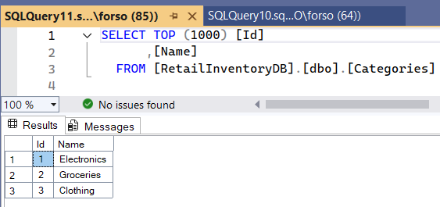
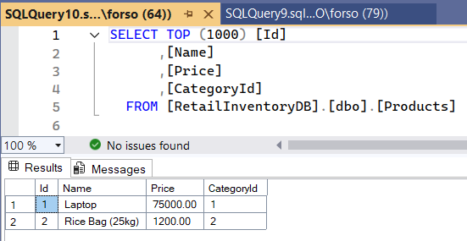
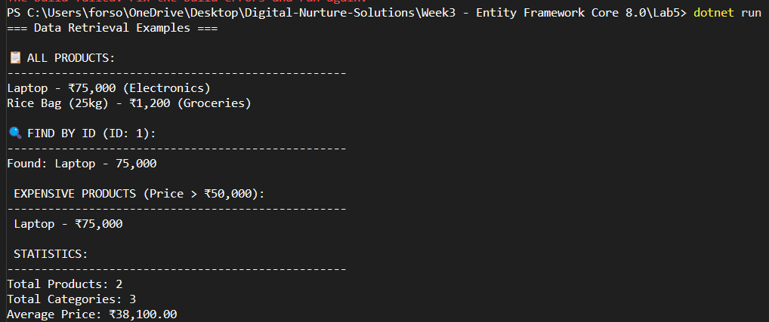

Code:
Lab5/Program.cs
using Lab2.Data;
using Lab2.Models;
using Microsoft.EntityFrameworkCore;

Console.WriteLine("=== Data Retrieval Examples ===\n");

try
{
using var context = new AppDbContext();

// 1. Retrieve All Products
Console.WriteLine("📋 ALL PRODUCTS:");
Console.WriteLine("".PadRight(50, '-'));

var products = await context.Products
.Include(p => p.Category)
.ToListAsync();

foreach (var product in products)
{
Console.WriteLine($"{product.Name} - ₹{product.Price:N0} ({product.Category.Name})");
}

// 2. Find by ID
Console.WriteLine($"\n🔍 FIND BY ID (ID: 1):");
Console.WriteLine("".PadRight(50, '-'));

var productById = await context.Products
.Include(p => p.Category)
.FirstOrDefaultAsync(p => p.Id == 1);

if (productById != null)
{
Console.WriteLine($"Found: {productById.Name} - {productById.Price:N0}");
}
else
{
Console.WriteLine("Product not found!");
}

// 3. FirstOrDefault with Condition
Console.WriteLine($"\n EXPENSIVE PRODUCTS (Price > ₹50,000):");
Console.WriteLine("".PadRight(50, '-'));

var expensiveProducts = await context.Products
.Include(p => p.Category)
.Where(p => p.Price > 50000)
.ToListAsync();

if (expensiveProducts.Any())
{
foreach (var product in expensiveProducts)
{
Console.WriteLine($" {product.Name} - ₹{product.Price:N0}");
}
}
else
{
Console.WriteLine("No expensive products found!");
}

// 4. Count and Statistics
Console.WriteLine($"\n STATISTICS:");
Console.WriteLine("".PadRight(50, '-'));

var totalProducts = await context.Products.CountAsync();
var totalCategories = await context.Categories.CountAsync();
var avgPrice = await context.Products.AverageAsync(p => p.Price);

Console.WriteLine($"Total Products: {totalProducts}");
Console.WriteLine($"Total Categories: {totalCategories}");
Console.WriteLine($"Average Price: ₹{avgPrice:N2}");
}
catch (Exception ex)
{
Console.WriteLine($"Error: {ex.Message}");
}

